* **Red Hat OpenShift on IBM Cloud**

**Proof of Technology**

Author: IBM Customer Success Manager

**Index**

Lab 1: Deploy and expose an application using Red Hat OpenShift console. 3

1. Login to the console 3

2. Deploy a new application 8

Lab 2: Deploy and expose an application using Red Hat OpenShift command line 16

1. Login with the command line 16

2. Deploy a new application 18

3. Expose the application 21

3.1 ClusterIP 21

3.2 Create Route 23

4. Clean all the artifacts 24

Lab 3. Source2Image (S2I) 25

1. Create the image from the Git repository 25

Lab 4. Logging 33

Lab 5. Monitoring 40

1. Dashboards 41

2. Using IBM Cloud Monitoring Service 44

# Lab 1: Deploy and expose an application using Red Hat OpenShift console.

## 1. Login to the console

You can access via Menu -> OpenShift -> Clusters

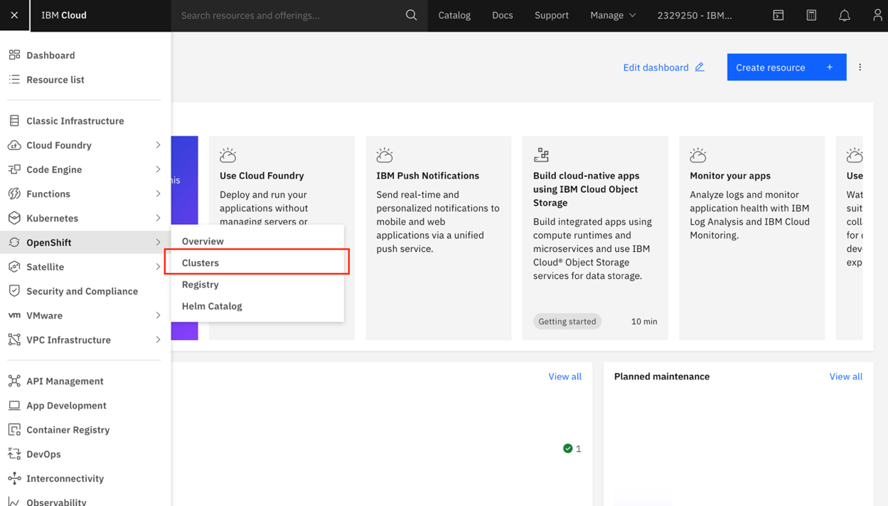

Select the cluster **assign to you** and click on.

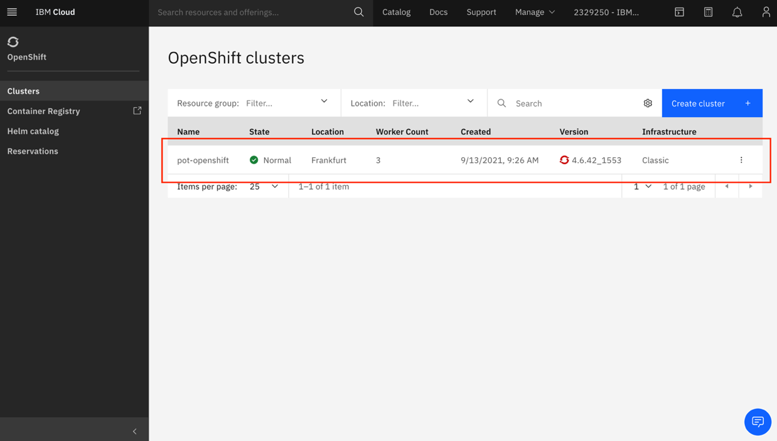

Then click on **OpenShift Web Console** button.

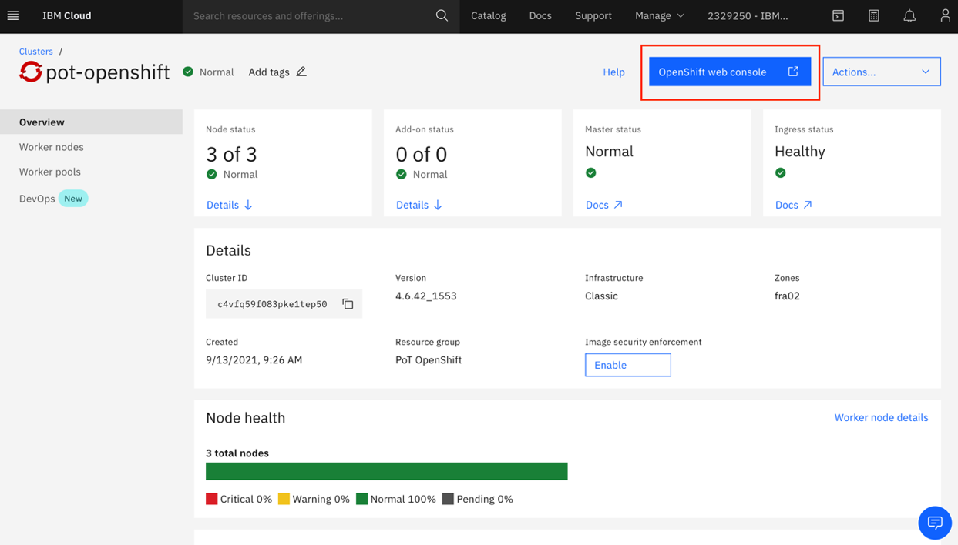

Alternative way: On the cluster list, on the ellipsis select OpenShift Web console.

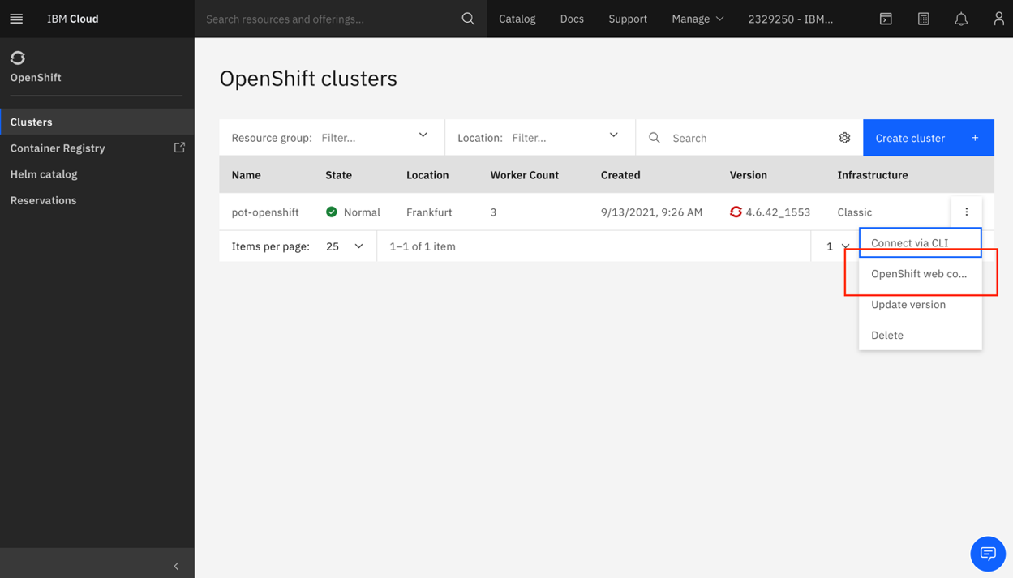

Once you know the URL, you can access directly via browser.

For example:

***https://console-openshift-console.pot-openshift-XXXXXXXXXXXXXXX-0000.eu-de.containers.appdomain.cloud/dashboards***

Console overview:

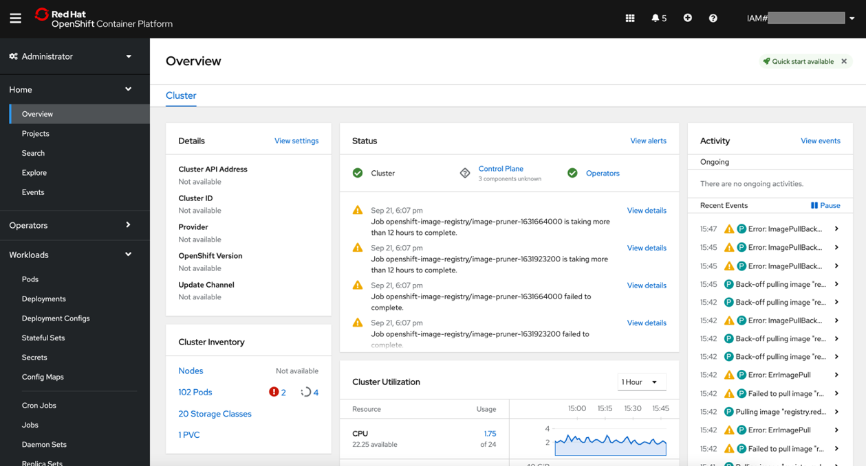

OpenShift offers two perspectives. You can use both if you have permissions.

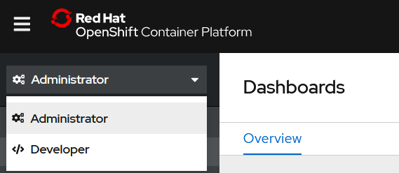

If you click on Home -> Projects.

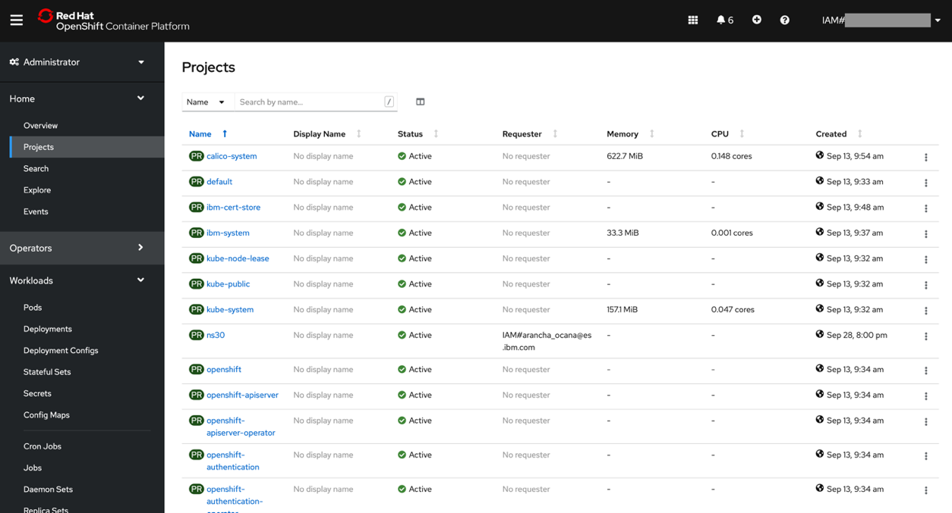

As you have rights to create Projects, you see the “Create Project” button.

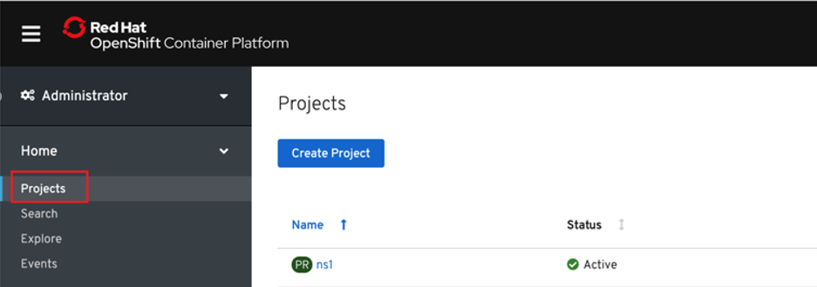

On the Administrator perspective, Home -> Overview, it will show a general dashboard with the health and status of the whole cluster. Something like this:

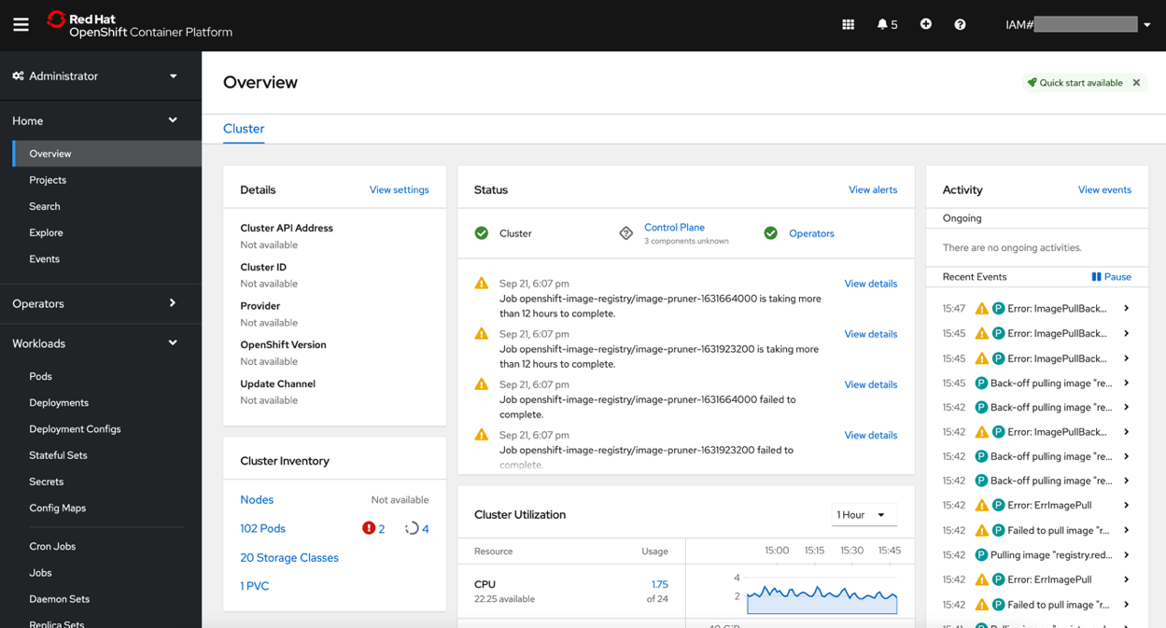

## 2. Deploy a new application

First, we are going to group our artifacts on a project (namespace). Administrator has created each namespace already and gave the permissions for each user.

We are going to deploy a WebSphere Liberty official image.

Select the “**Developer**” perspective from left panel and click “**+Add**”:

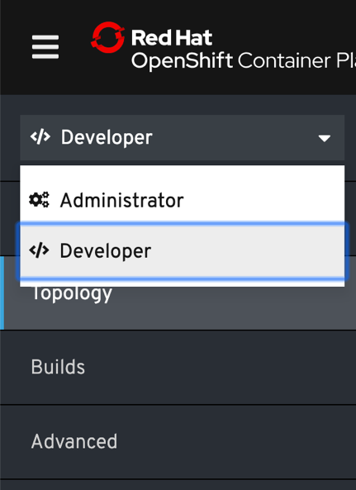 ´ 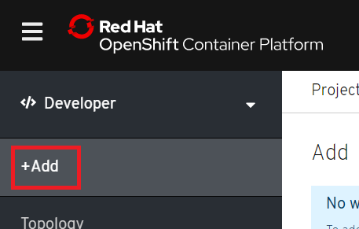

Change to the project where you have permissions and click “**Container Image**”, for example if you are user “user30” select project “ns30” in the “Project” field:

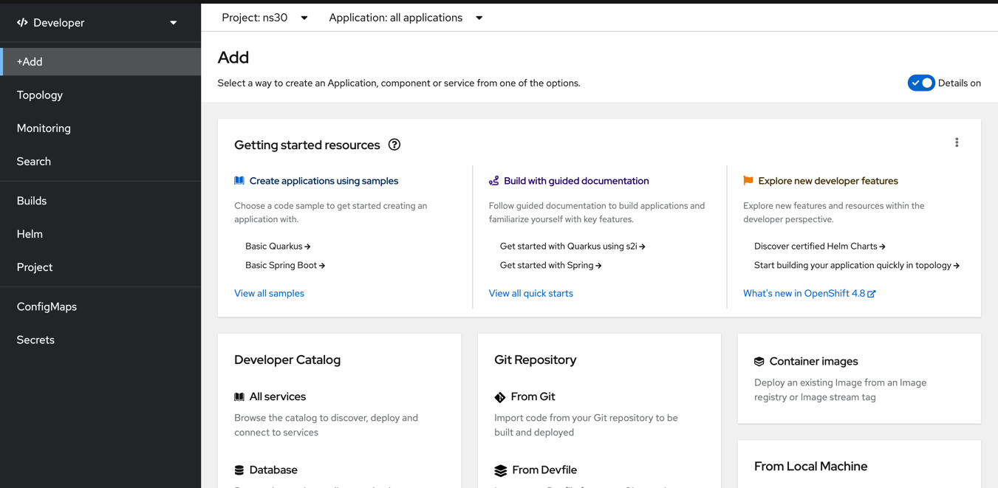

Enter the following information:

**Image**:

Image Name: websphere-liberty:19.0.0.9-webProfile8-java11

**General**:

Application Name: websphere-liberty-app

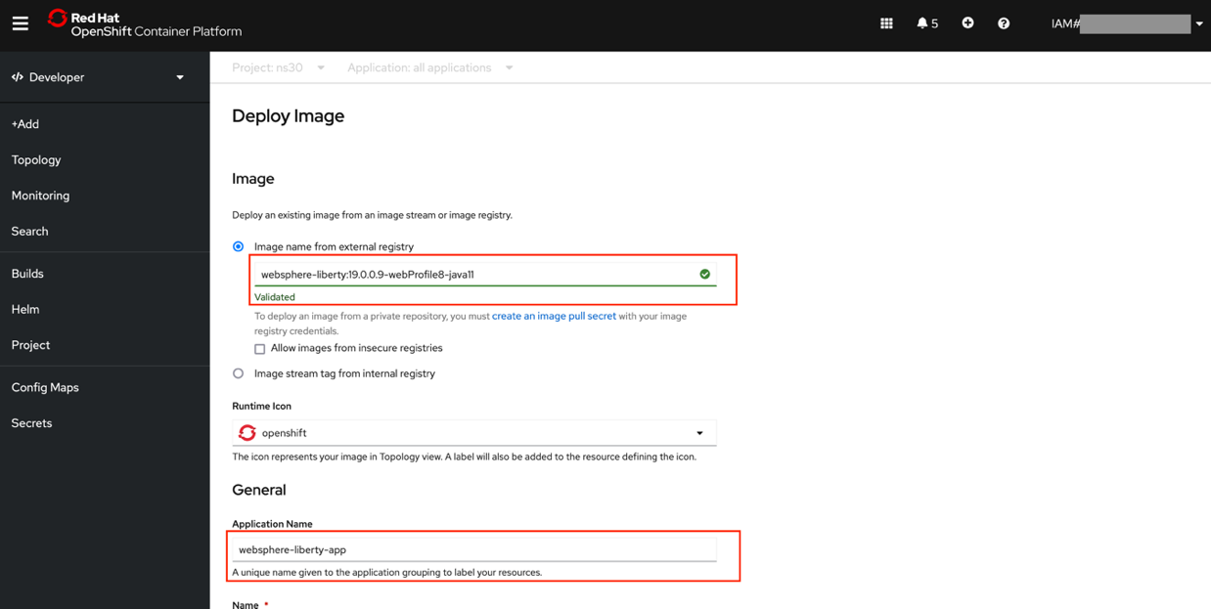

Advanced Options:

Create a route to the application: checked

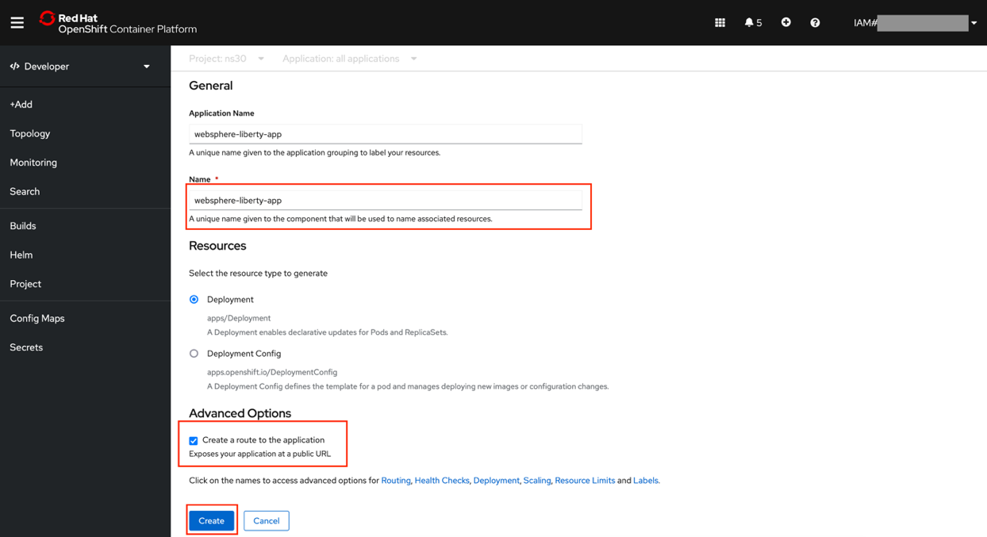

And then click “**Create**” button.

If everything goes well, you should see “**Topology**” view and the application deploying…

Press the **websphere-liberty-app** icon from the middle of the screen to see the status:

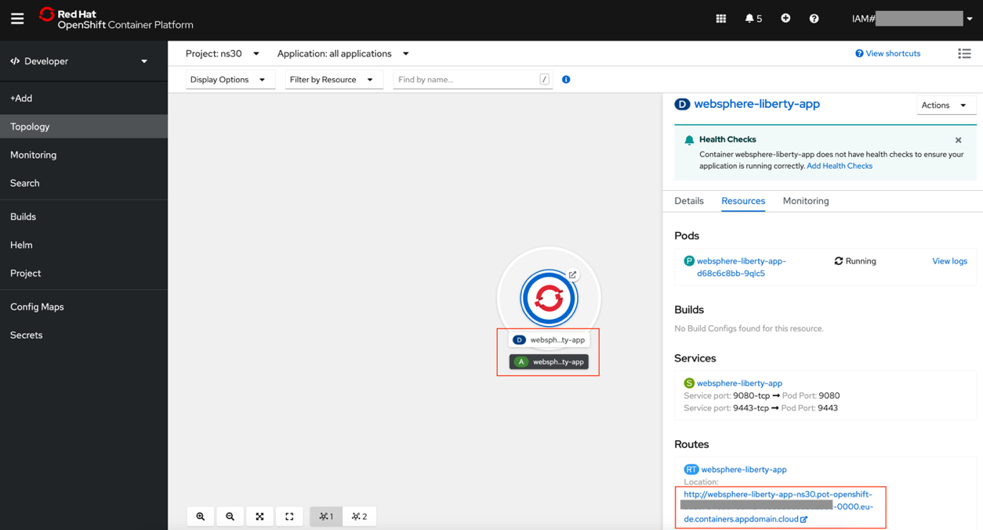

As you can see, a route has been automatically created for the application. Something like:

***http://websphere-liberty-app-nsX.pot-openshift-XXXXXXXXXXXXXXX-0000.eu-de.containers.appdomain.cloud***

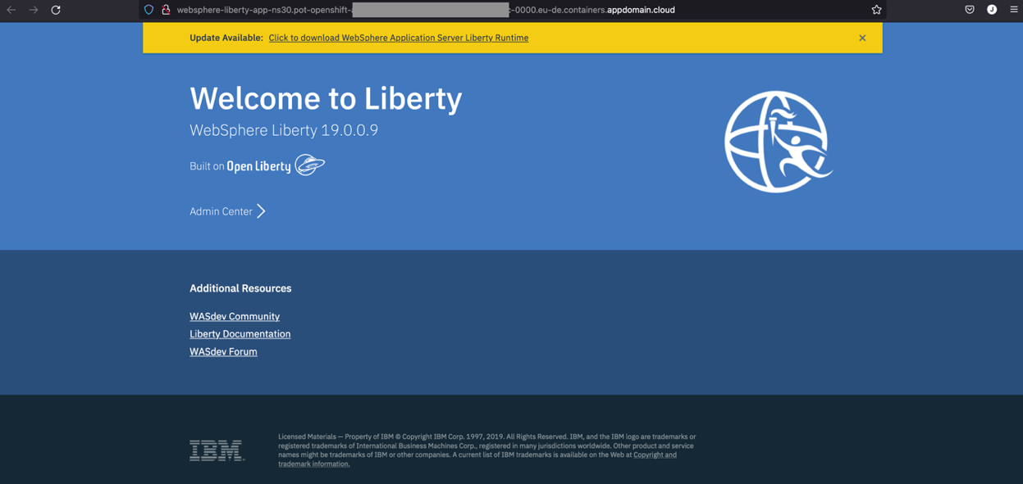

Now, from the same view we were before we can click on the “**pods**” link to check events and logs for example:

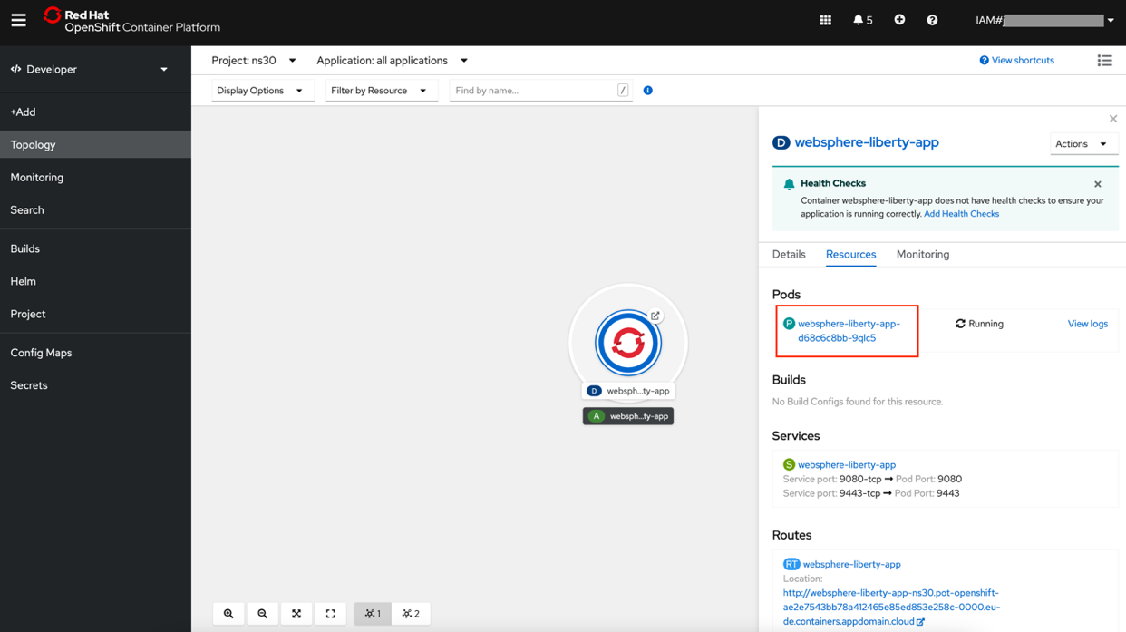

Few seconds are needed to see info on the **Pod Details** graphs.

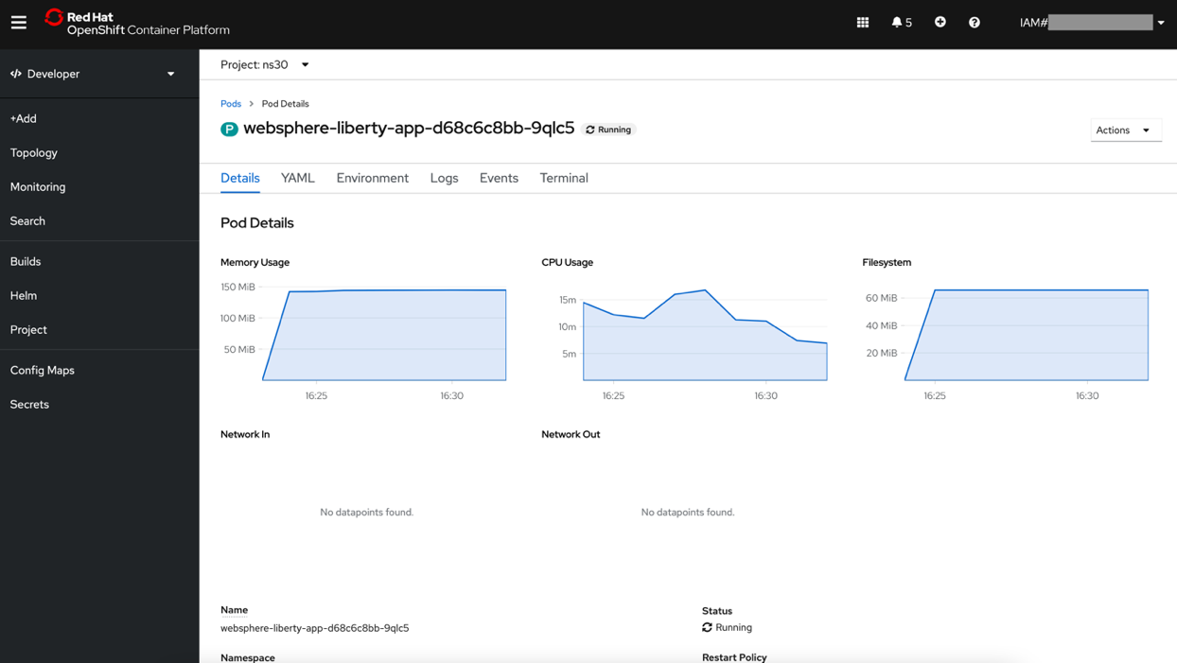

Click “**Events**” tab. This is the first place to look for errors in runtime or during deployment:

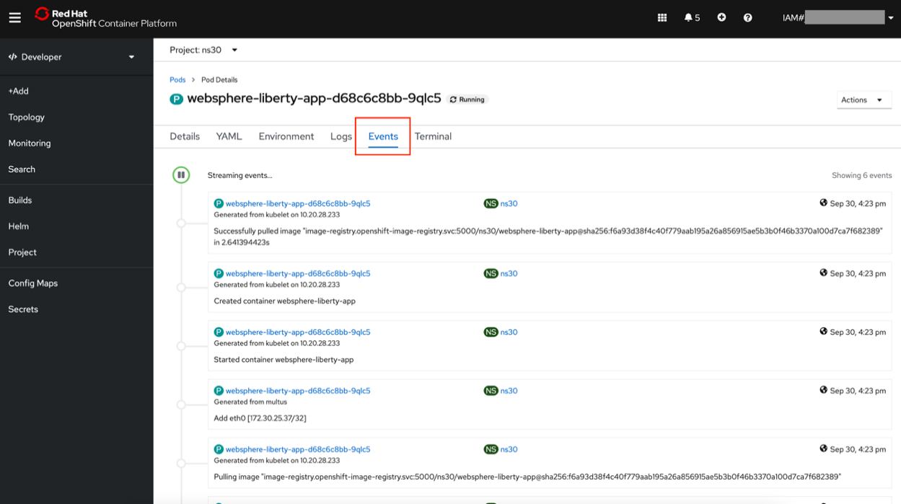

And “**Logs**” tab:

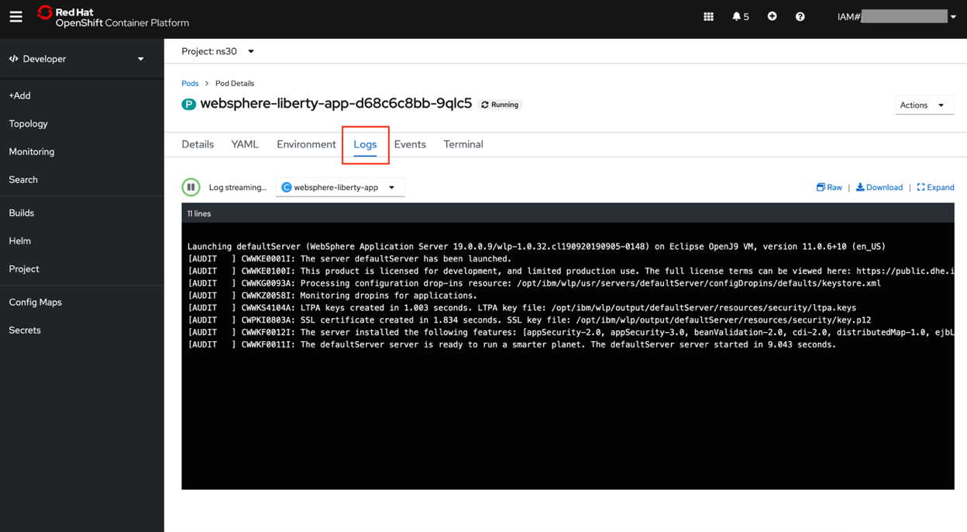

“**Terminal**” tab is also useful sometimes because you get a console inside the container itself:

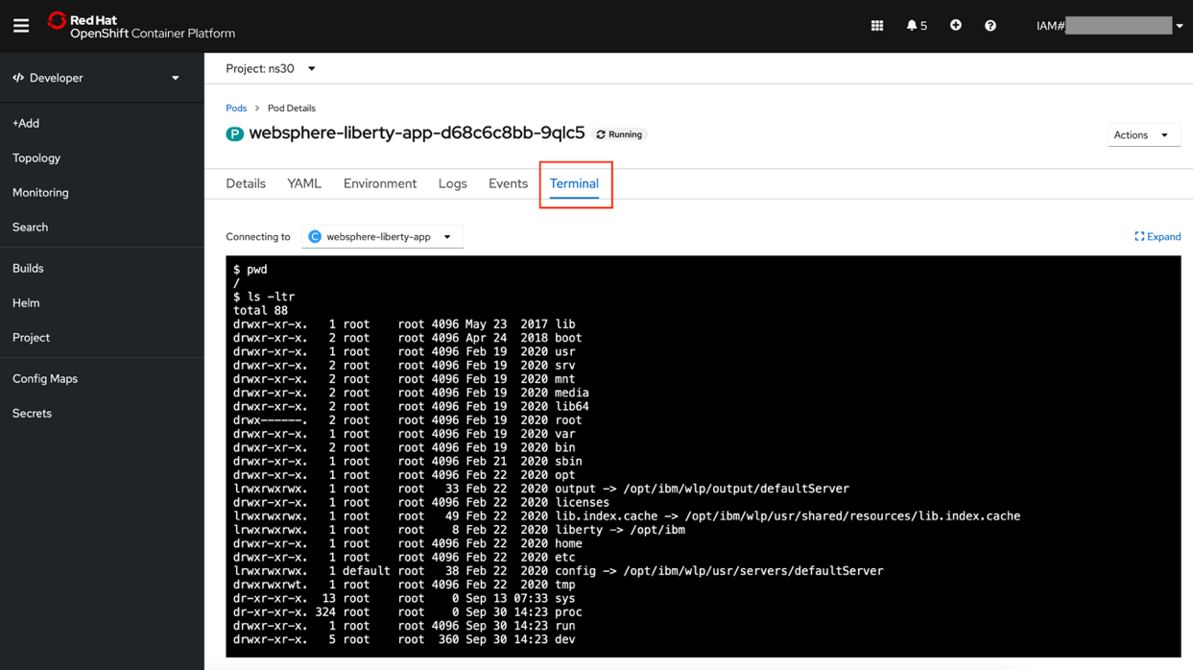

In next section we will do the same but from command line understanding all the concepts that happened automatically under the covers when we used OpenShift web console.

You can see the **Service** created using the Administration perspective:

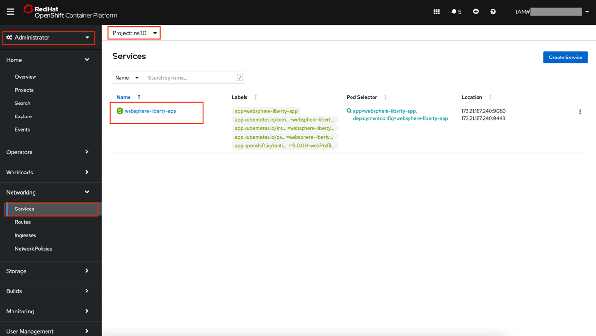

Also, you can see the **Route** created:

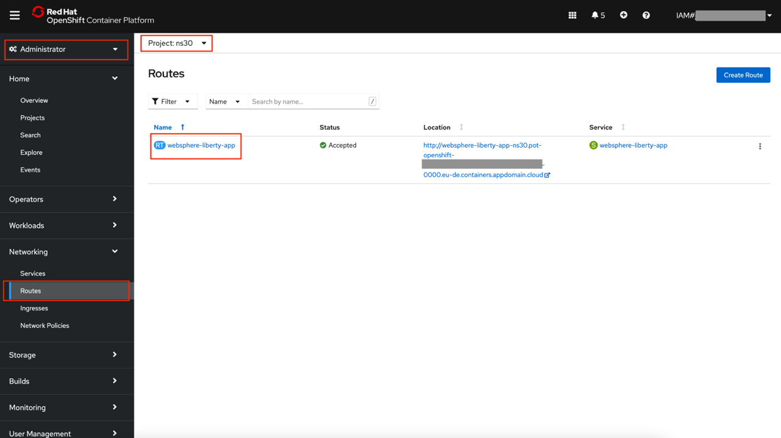

And the **ImageStream**:

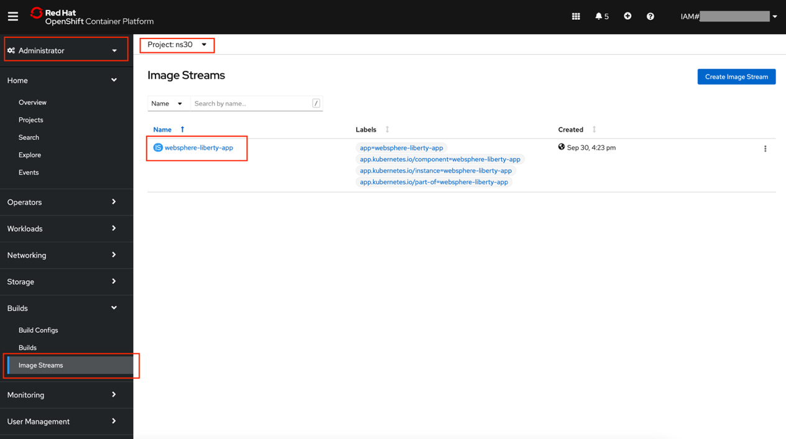

# Lab 2: Deploy and expose an application using Red Hat OpenShift command line

## 1. Login with the command line

OpenShift can be configured using different Identity providers (LDAP, HttpPassword ...). But normally, you will login using a token. To get it the first time you can:

Browse to the OpenShift web console and from the dropdown menu in the upper right of the page, click **Copy Login Command**:

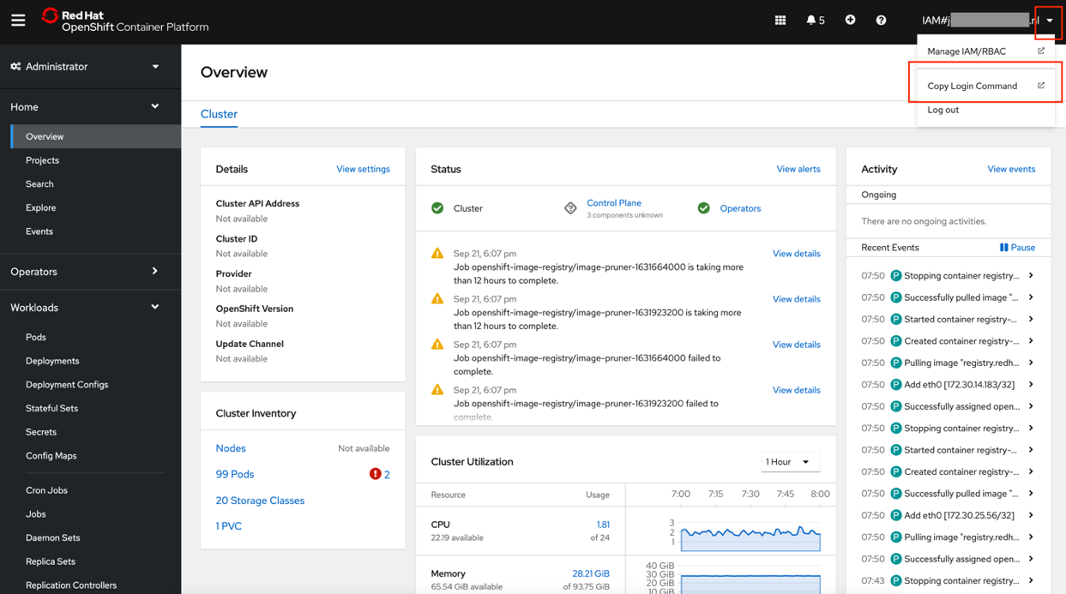

On next page, click the "Display Token" link and copy the "Log in with this token" command line:

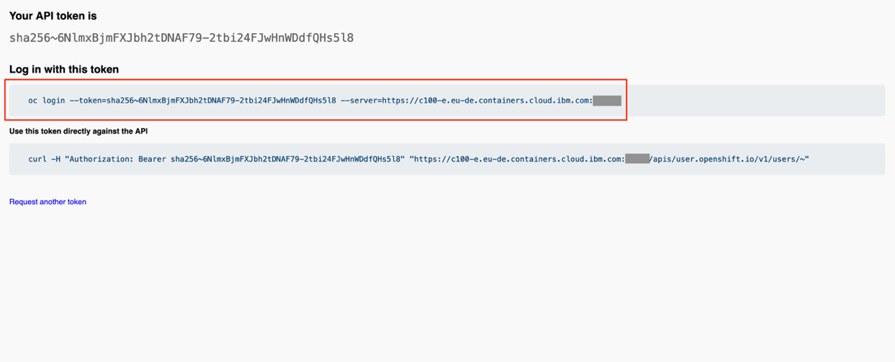

Paste the copied command in your terminal (where **oc** CLI is installed).

|  |
| --- |
| **Note**:  To carry out the workshop, a virtual server has been created where users can access to perform the exercises using CLI. Before starting the workshop, all users receive an email with some access credentials. Ask the workshop manager if you have lost your access credentials. |

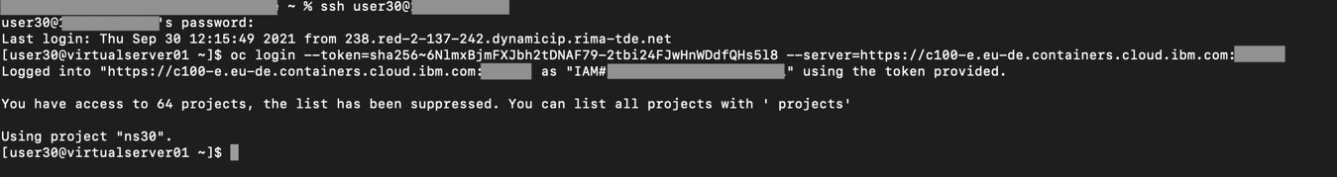

If login is successful, command result gives the number of projects you have permissions to, and which one is the default. As you have Reader rights, you’ll see all of them, but you just have written permission on yours.

You can set your project as the default via:

|  |
| --- |
| **oc project ns30** |



We have installed the OpenShift command line for you in our server. But if you would like to install the command line in your own desktop.

Click on **Question** button, select **Command Line Tools** and follow the instructions from OpenShift console:

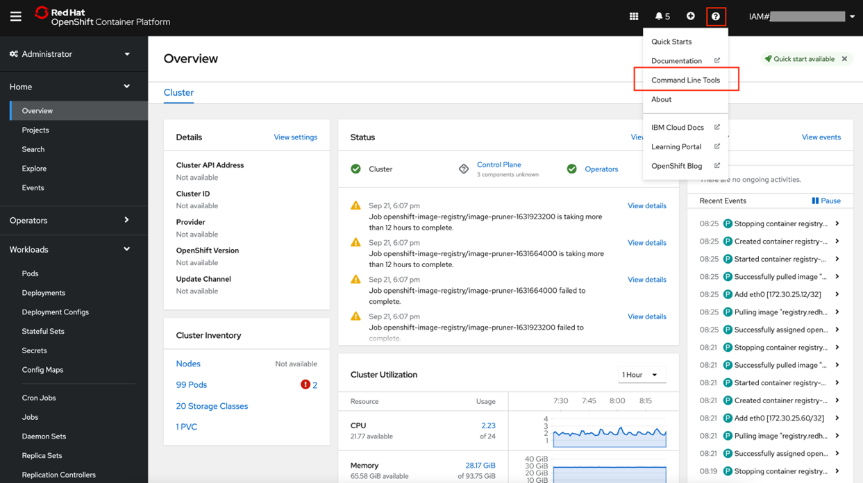

## 2. Deploy a new application

|  |
| --- |
| **Reference**:  <https://docs.openshift.com/container-platform/4.6/applications/deployments/what-deployments-are.html> |

Now we can execute commands against the cluster.

First, let’s make sure we clean all existing artifacts from previous lab. To remove the deployment. On Administrator perspective:

**Workloads -> Deployments**, on the websphere-liberty-app ellipsis, select **Delete Deployment**

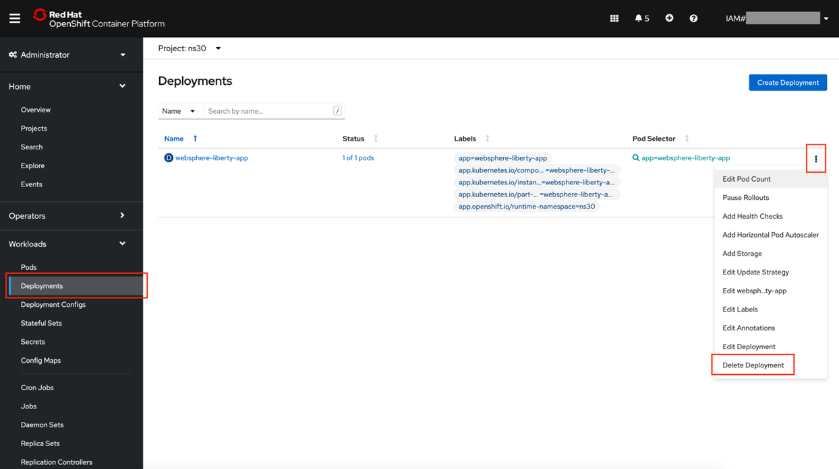

Select **Delete** when ask about confirmation (Check box for “**Delete dependent object of this resource**” must be marked)

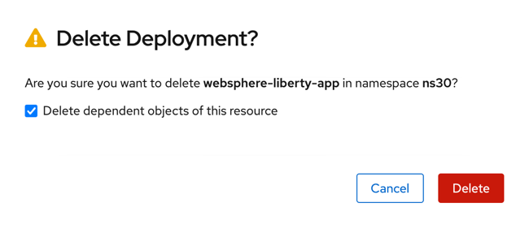

|  |
| --- |
| **Note**:  The above check doesn’t delete the **Route**, **Service** and **ImageStream**. Go to each section and delete them manually too. |

Example with Networking -> Services

Verify and repeat same procedure with:

* **Networking -> Services**
* **Builds -> Image Streams**

Once verified that the resources have been deleted, let’s define our first OpenShift deployment. Create a file called ***was-deployment.yaml*** file with this content:

|  |
| --- |
| **apiVersion: apps/v1**  **kind: Deployment**  **metadata:**  **name: websphere-liberty-app**  **namespace: ns30**  **spec:**  **selector:**  **matchLabels:**  **app: websphere-liberty-app**  **replicas: 1**  **template:**  **metadata:**  **labels:**  **app: websphere-liberty-app**  **spec:**  **containers:**  **- name: websphere-liberty-app**  **image: websphere-liberty:19.0.0.9-webProfile8-java11**  **ports:**  **- containerPort: 9080** |

|  |
| --- |
| **Note**:  The indentation spaces are very important, pay attention when executing the copy and paste. If you have problems with the copy and paste, all the files used in the labs are in the artifact folder under the user home folder. |

The file already exists in /artifacts directory. Execute:

|  |
| --- |
| **git clone https://github.com/karinalopez22/taller-roks-files**  **cd taller-roks-files**  **oc create -f was-deployment.yaml** |



If everything went well, your pod should be running:

|  |
| --- |
| **oc get pods -n ns30** |



Pod could be on *ContainerCreating* Status. Let’s wait few seconds and try again.

Application is running but it can’t be accessed.

We need to define a service to expose it internally or externally. Let’s see how in next section.

## 3. Expose the application

|  |
| --- |
| **Reference**:  https://docs.openshift.com/container-platform/4.6/networking/understanding-networking.html |

### 3.1 ClusterIP

Let’s start exposing the application just internally via ClusterIP service type. As we did before, create a file called *was-service1.yaml* with this content:

|  |
| --- |
| **apiVersion: v1**  **kind: Service**  **metadata:**  **name: websphere-liberty-service1**  **namespace: ns30**  **spec:**  **selector:**  **app: websphere-liberty-app**  **type: ClusterIP**  **ports:**  **- protocol: TCP**  **port: 9080**  **targetPort: 9080** |

|  |
| --- |
| **Note**:  The indentation spaces are very important, pay attention when executing the copy and paste. If you have problems with the copy and paste, all the files used in the labs are in the artifact folder under the user home folder. |

Once you have the file created, execute:

|  |
| --- |
| **oc create -f was-service1.yaml** |



If everything went well, your service should be deployed, and the application accessed from inside the cluster (this means other pods running in it):

|  |
| --- |
| **oc get services -n ns30** |



|  |
| --- |
| **Note**:  If you don’t find the service, double check your default project (**oc projects** or add **--all-namespaces** to oc get services command). |

Executing following command, you also can see the mapping to the real endpoints (your application pods). It doesn’t matter if your application escalates up, escalates down, moves to other worker… that will be managed internally by the service. You just access to the service name or its internal IP:

|  |
| --- |
| **oc describe service websphere-liberty-service1 -n ns30** |

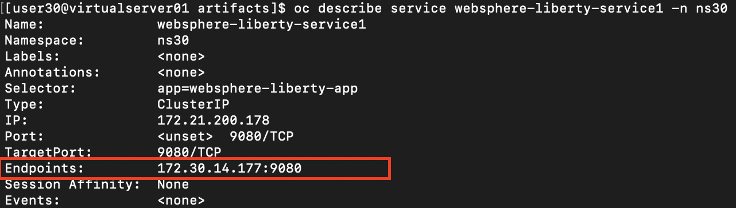

If *Endpoints* is empty, it means the application has not been found. Review the steps on the previous chapter.

|  |
| --- |
| **oc get pods -o wide -n ns30** |



But as we said, this type of service is accessible only from inside the cluster itself. We have other two types of services to expose the application externally.

### 3.2 Create Route

To make the exposed service publicly accessible, you need to create a public route. First, go to **Networking > Routes** from the Administrator Perspective on the web console, and then click **Create Route.**

Fill in the information as follows and click Create (you can leave all but the following fields empty):

* Name: websphere-liberty
* Service: websphere-liberty-service1
* Target Port: 9080→9080(TCP)

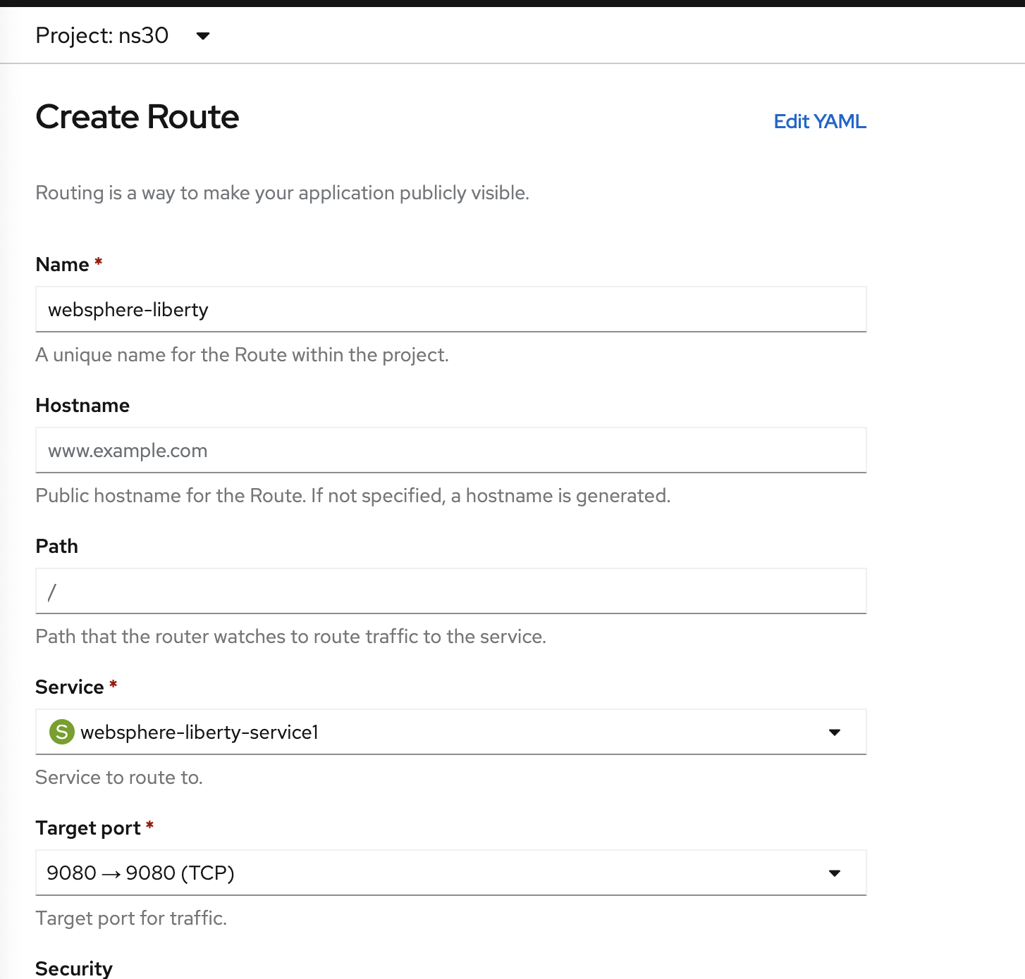

Once you create the route, you are redirected to the Route Overview, where you can access the external route from the URL under Location as shown in the following screenshot. You have created the Route successfully, and you have a publicly accessible endpoint URL that you can use to access your websphere liberty application.

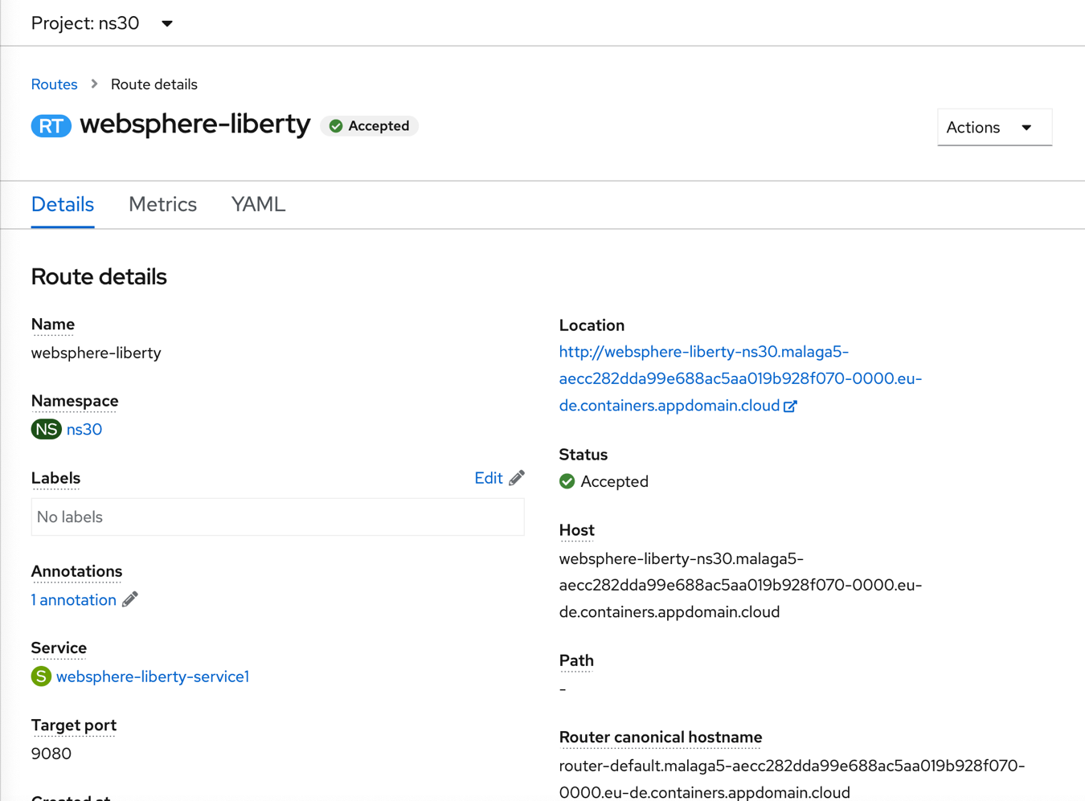



## 4. Clean all the artifacts

To delete all artifacts, you can use the previous files:

|  |
| --- |
| **oc delete -f was-service1.yml -n ns30**  **oc delete -f was-deployment.yml -n ns30** |

Go to **Networking > Routes > Websphere-liberty > Delete Route**

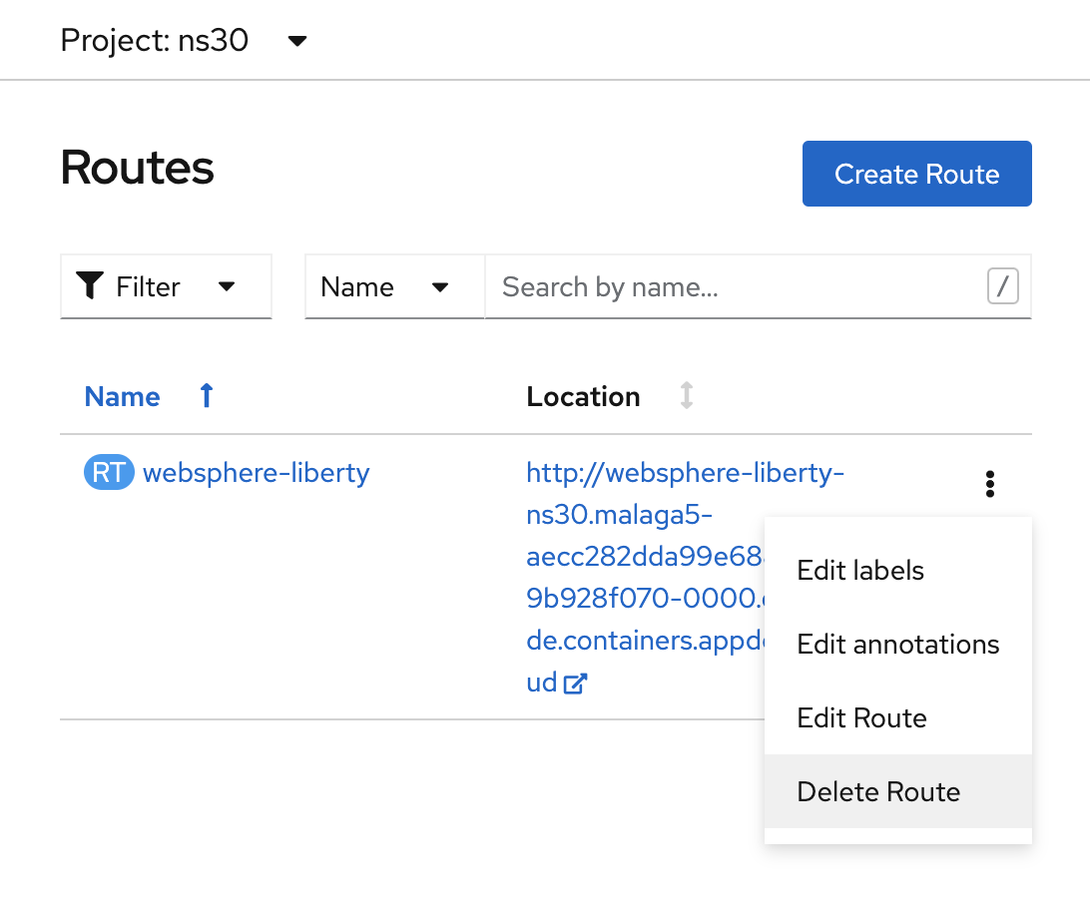

# Lab 3. Source2Image (S2I)

Source-to-Image (S2I) is a tool for building reproducible, Docker-formatted container images. It produces ready-to-run images by injecting application source (from a Git repository) into a container image and assembling a new image. The new image incorporates the base image (the builder) and built source and is ready to use with the buildah run command. S2I supports incremental builds, which re-use previously downloaded dependencies, previously built artifacts, etc.

## 1. Create the image from the Git repository

From the Developer perspective, select “+Add” and it show different options to deploy an application (we have seen some of them on previous labs). Select in this case “From Git”:

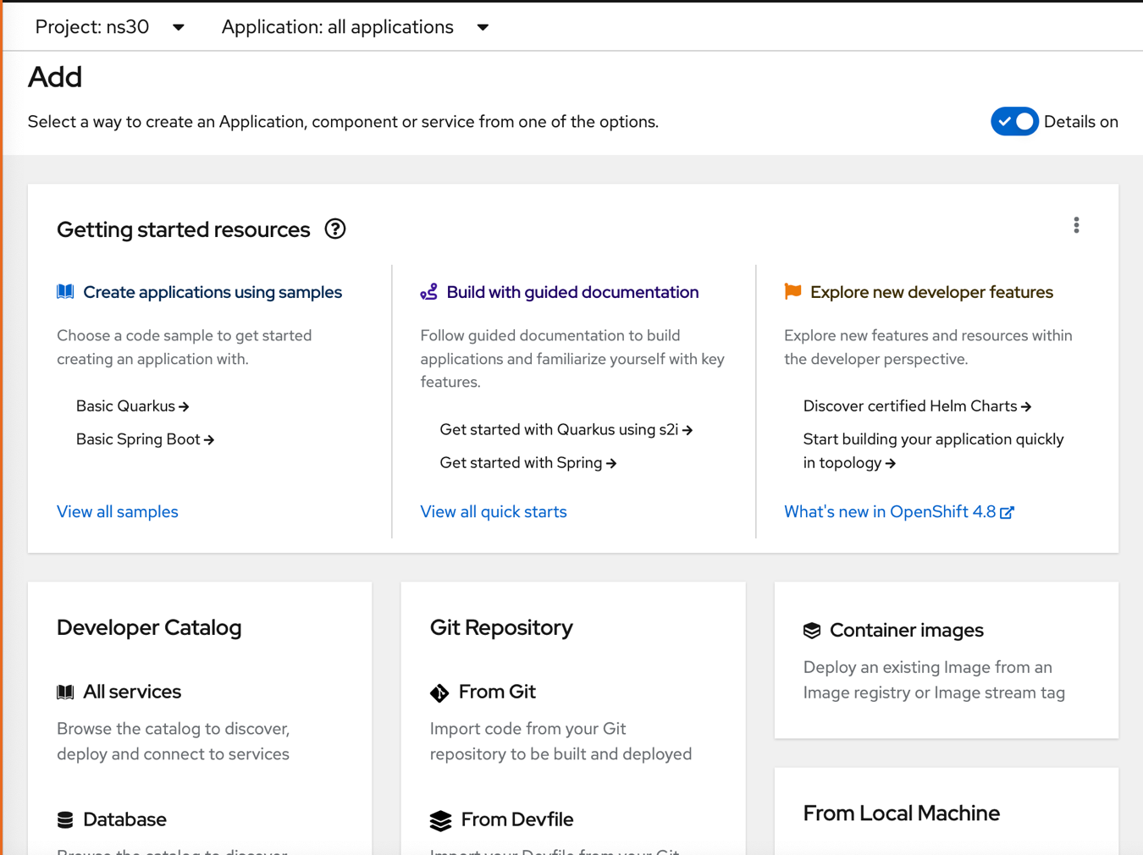

Use following git content that has the node.js code **“https://github.com/svennam92/node-s2i-openshift”**

You have to Click outside the text field in order to check the Git URL is valid. You can see the “Validated” message and green ACK.

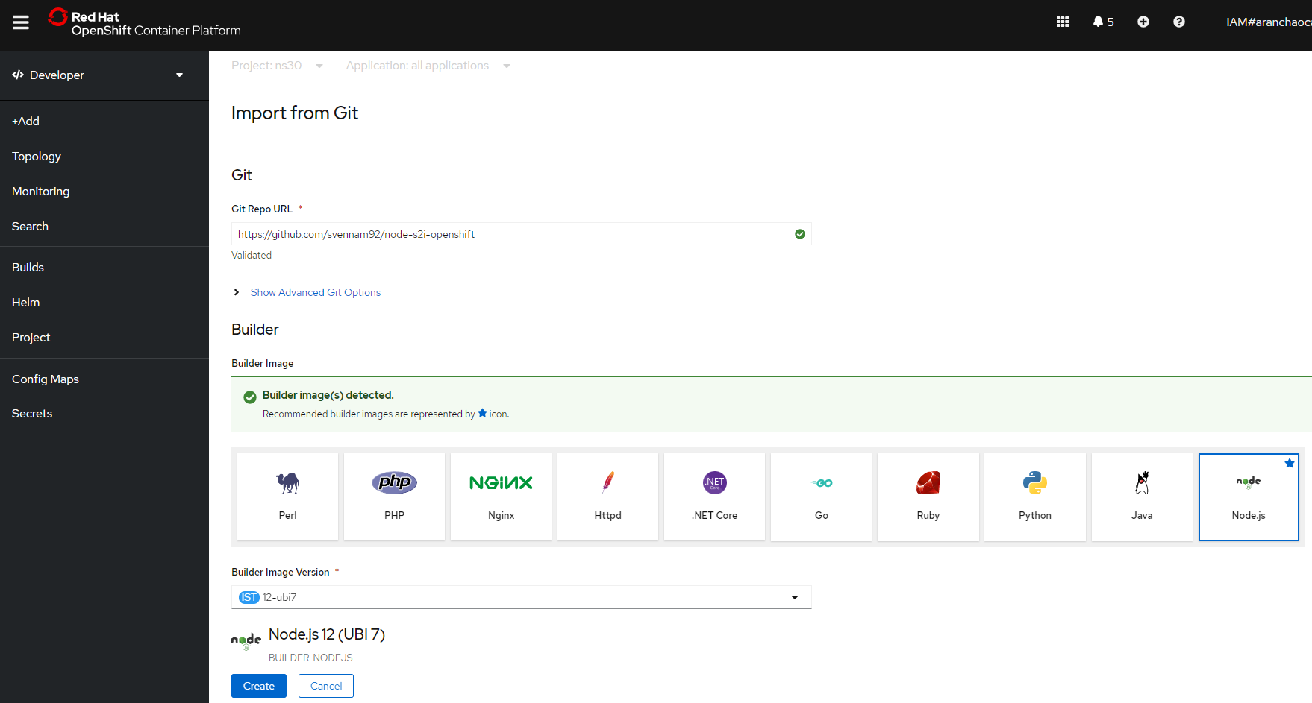

You can observe the recommended Builder Image(s) detected has been marked as a and It has selected Node.js !!!

Double check the name of the app and select the creation of a route automatically.

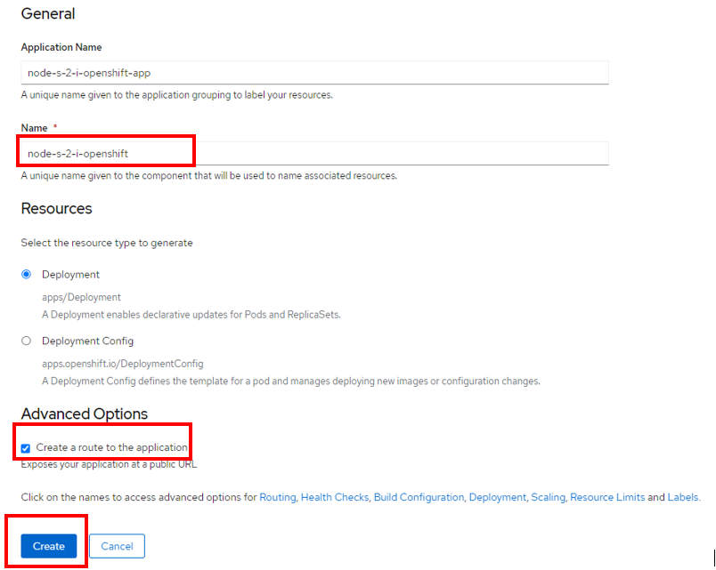

Click “Create” in order to start the process of installation.

You can see there is a new application on Topology.

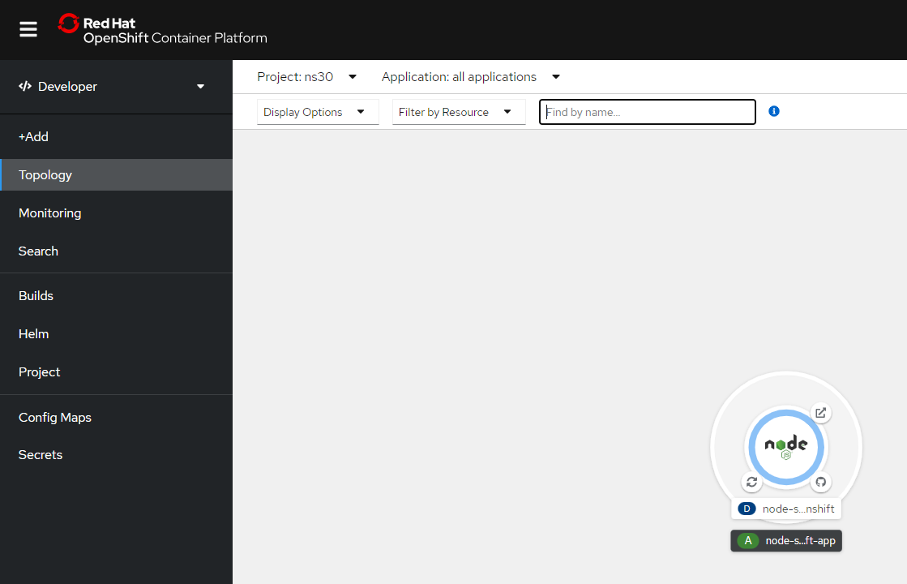

It takes a while. You can see the application moves from one state to another

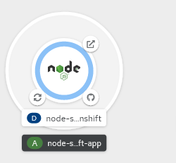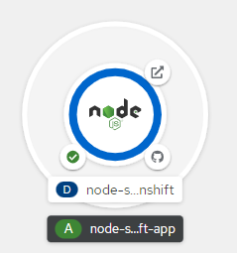

and the steps that are executed if you click on the middle of application.

When the application be ready deployed, it will appear on green:

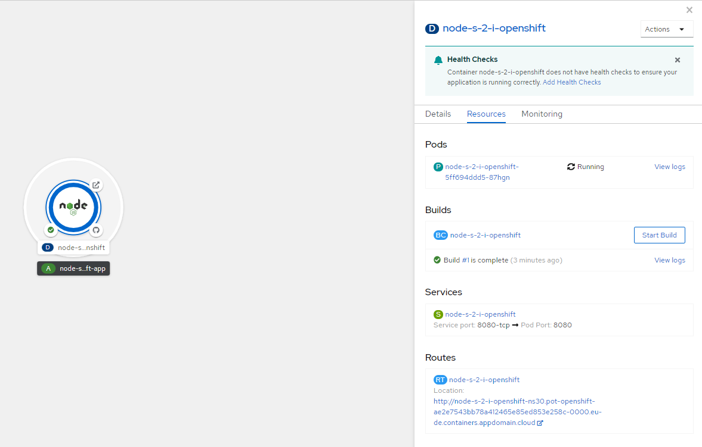

A route has been generated for you. Click on it in order to access to the new application. It will open a new tab

**http://node-s-2-i-openshift-nsX.pot-openshift-XXXXXXXXXXXXXXX-0000.eu-de.containers.appdomain.cloud/login.html**

Enter a dummy user and password:

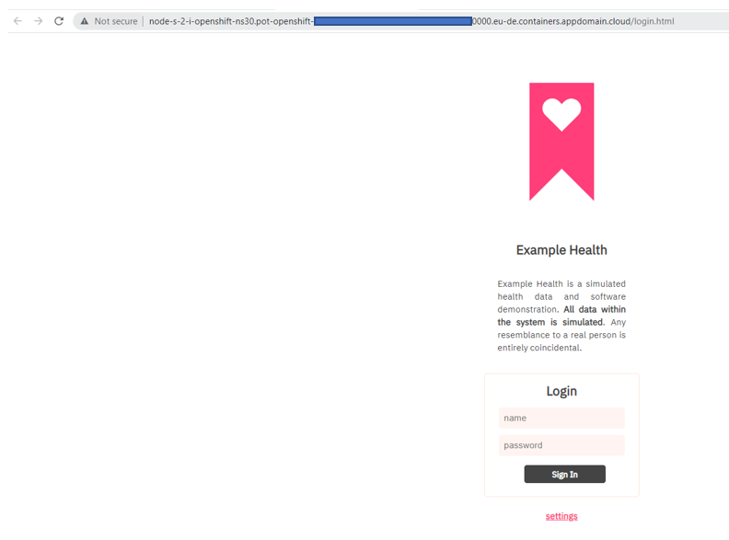

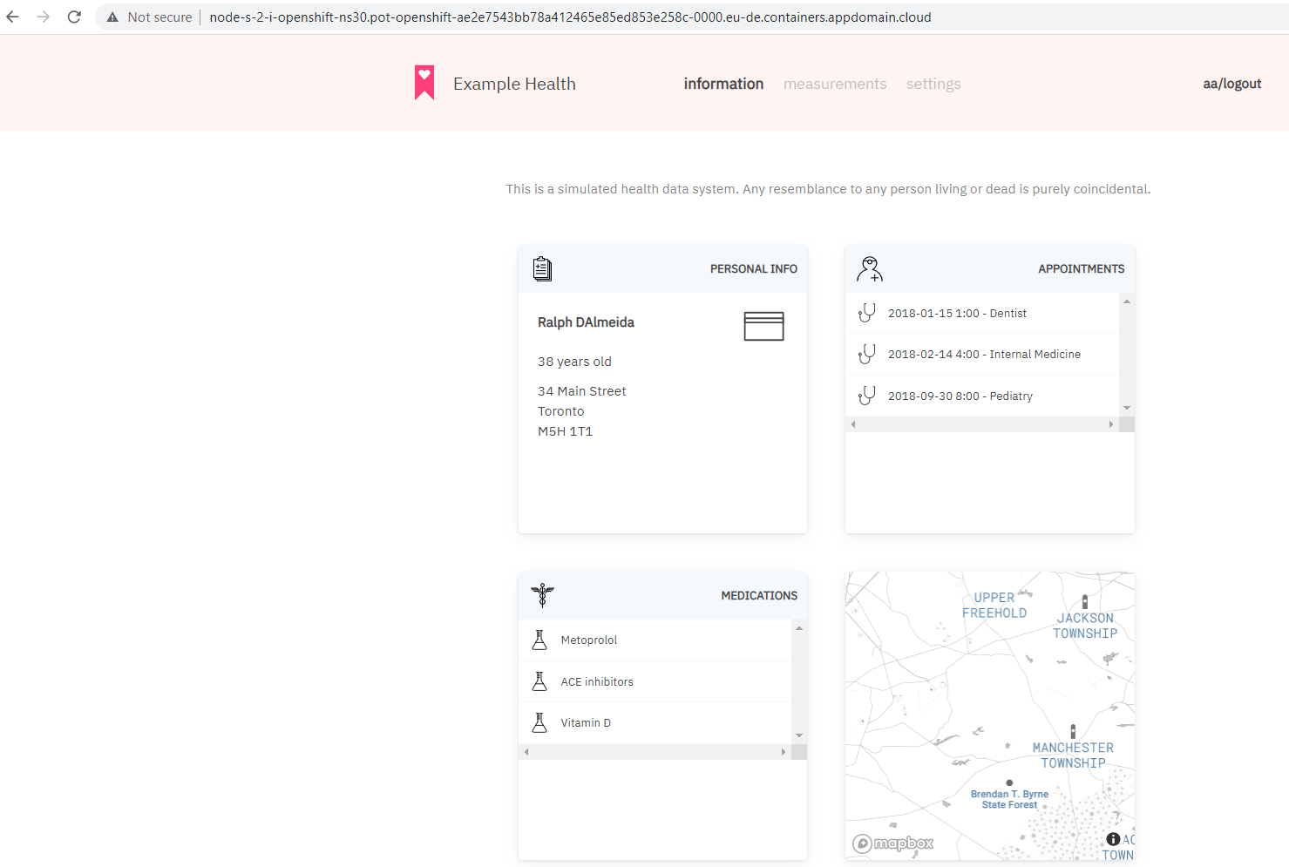

You can see build was done:

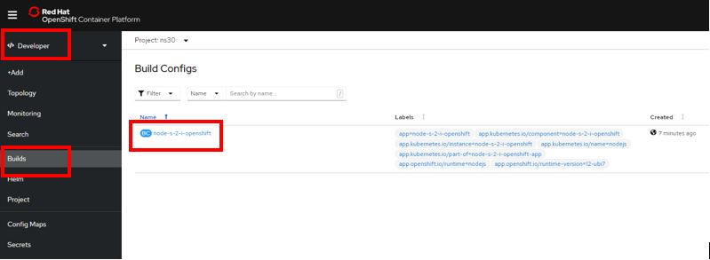

And the image was added such as ImageStream. Change to the Administrator perspective:

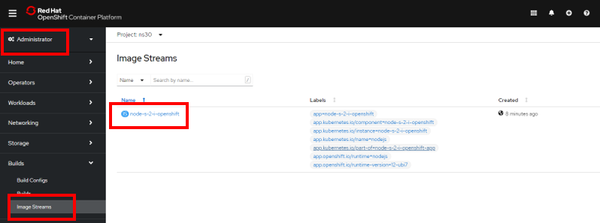

# Lab 4. Logging

By default, docker and OpenShift can access to the logs that a container prints to its STDOUT and STDERR. There are also options to access to internal or custom containers logs.

As we are using OpenShift on IBM Cloud we are able to use very easily the IBM Cloud Logging Service in order to centralize all the logs of your clusters and services.

You can access via Genera Menu -> Observability

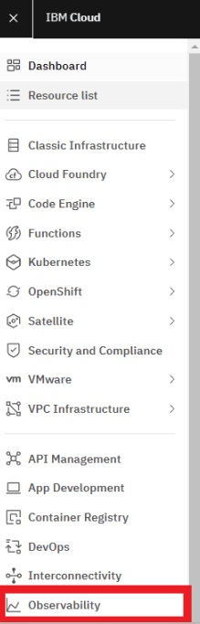

Go to Logging and Select “Open dashboard” . It’ll open another tab:

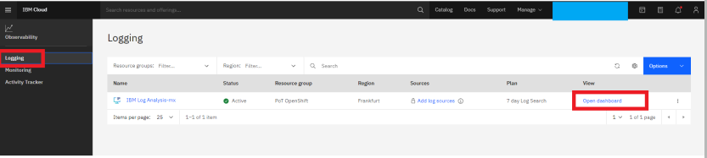

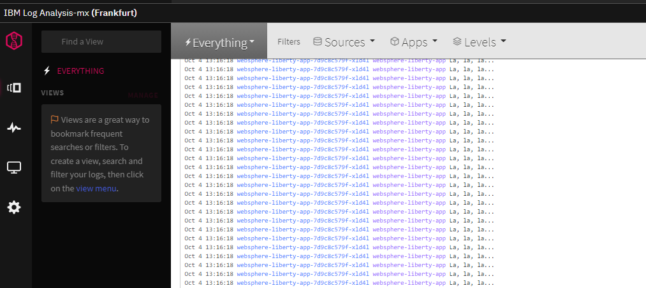

Select the application on Apps, and click Apply:

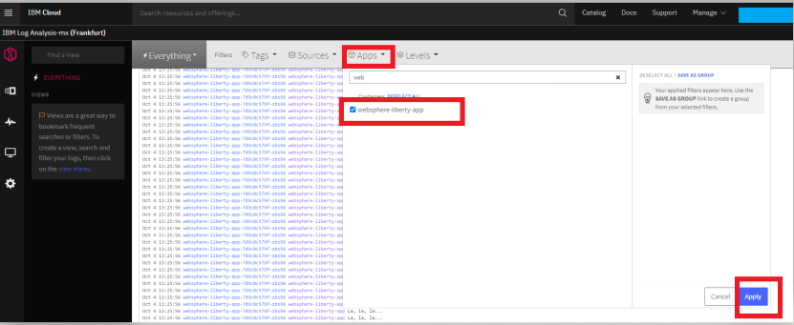

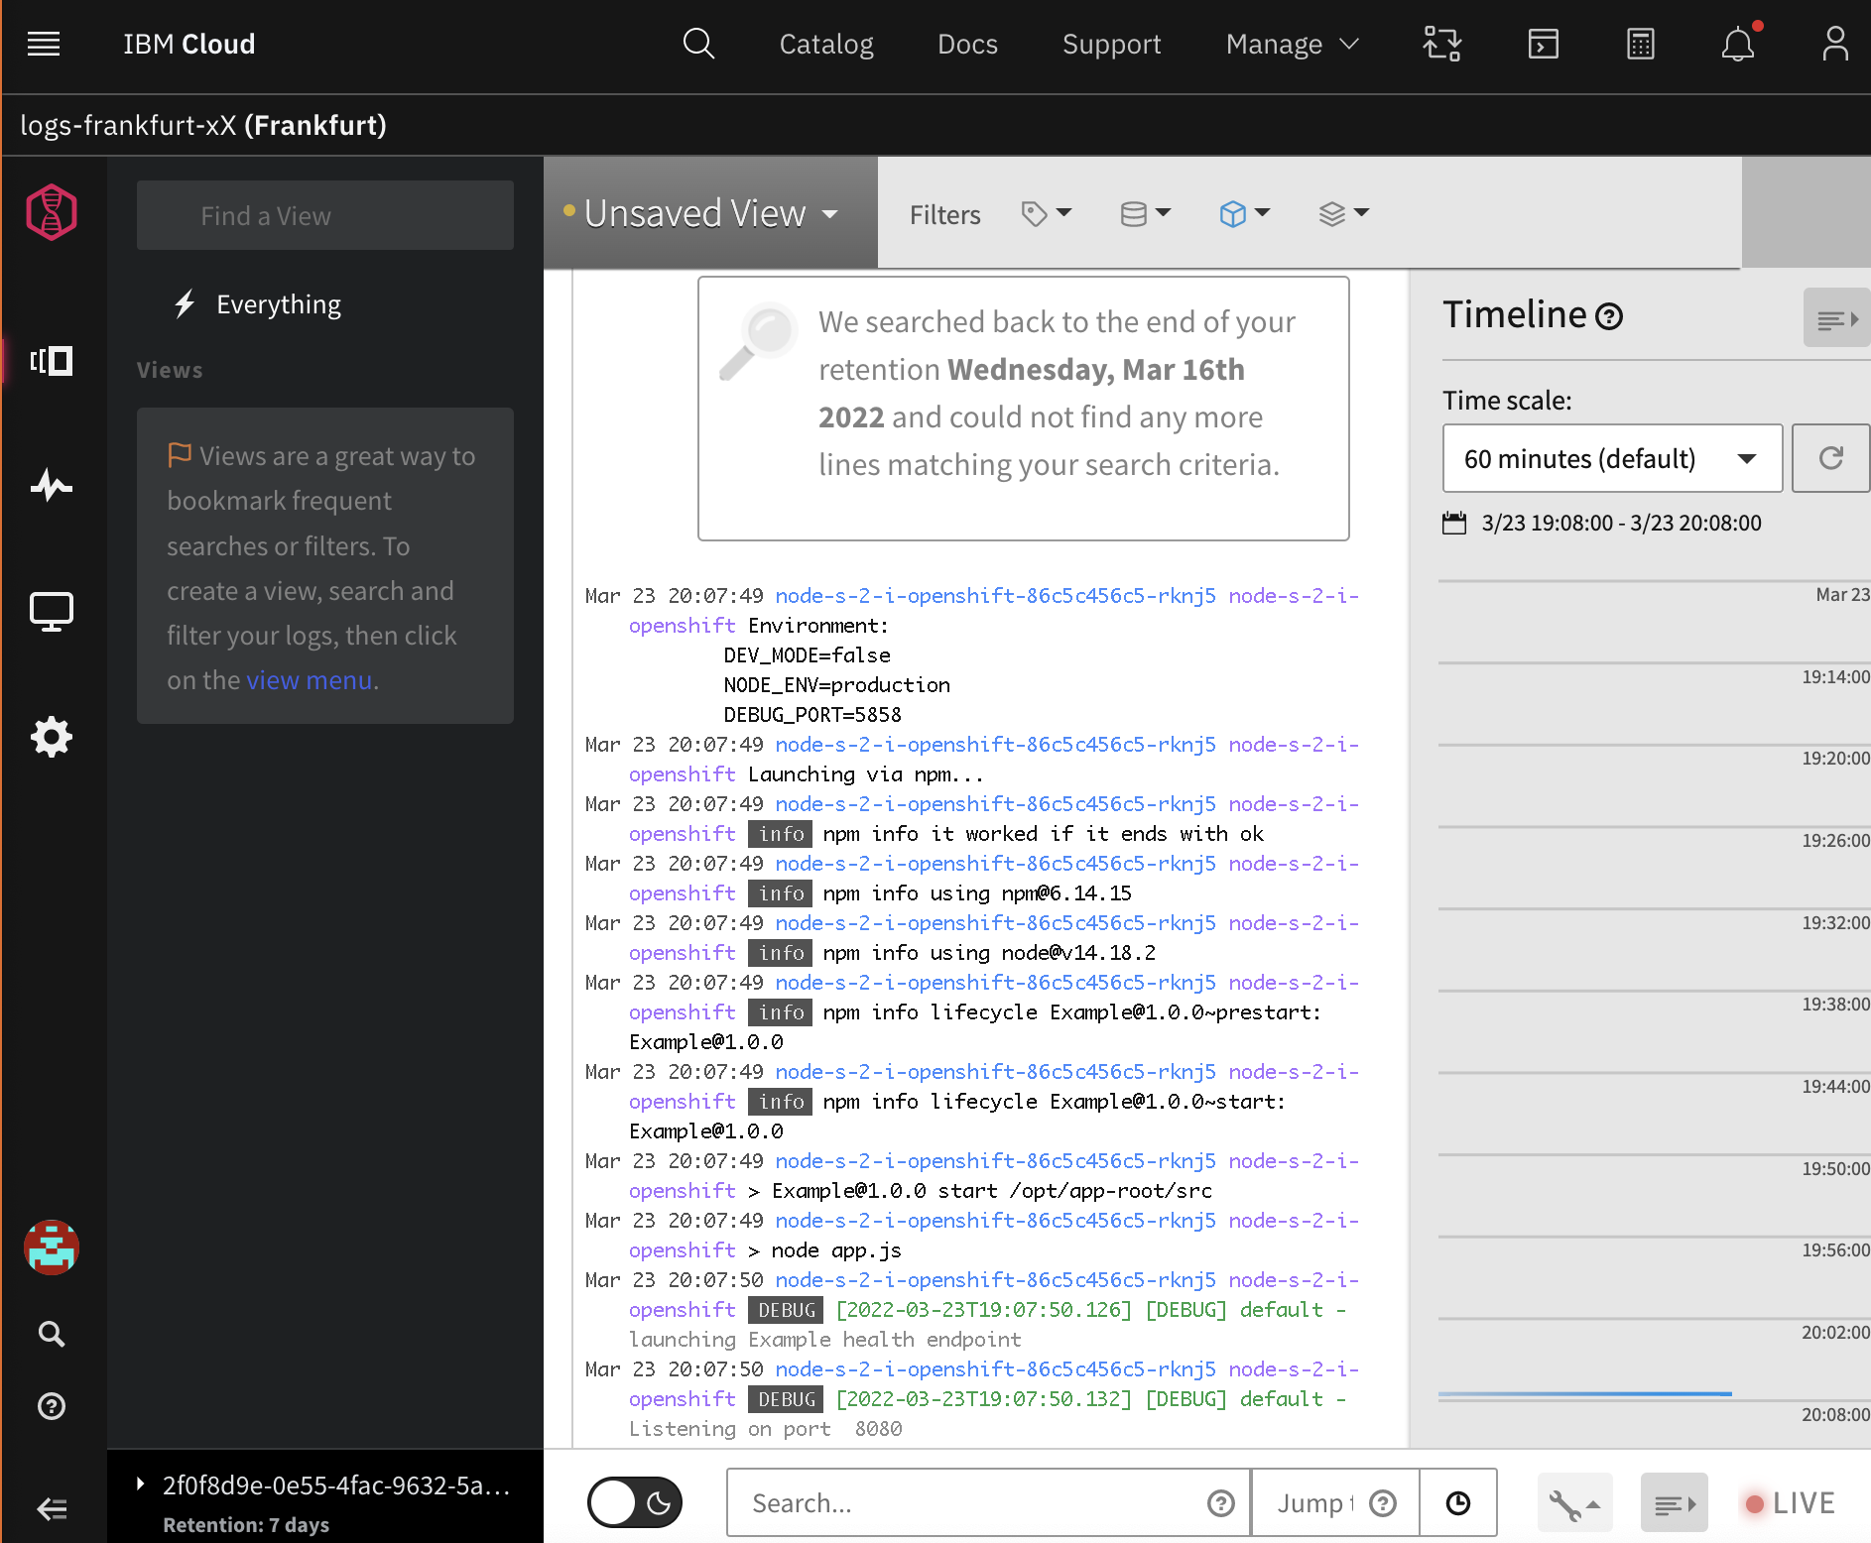

You can click on one of the messages to see its details:

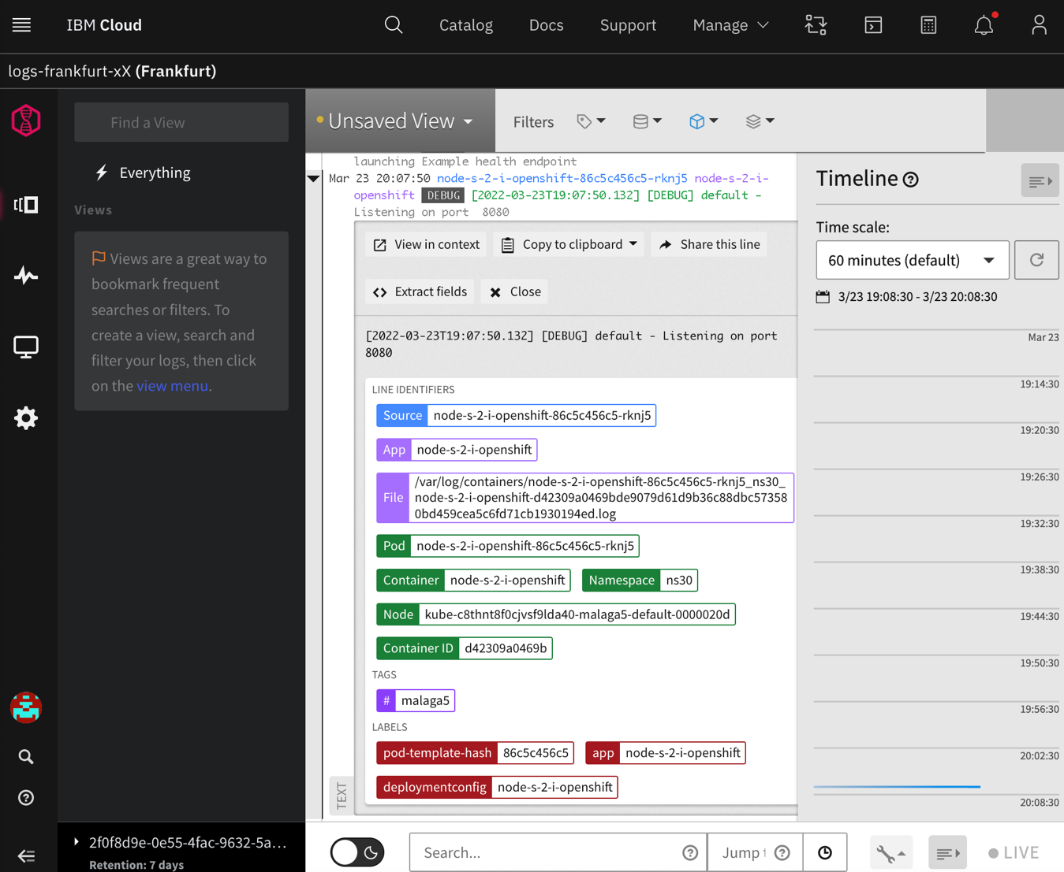

On the bottom you can filter by text (using pod name for example) to filter each application:

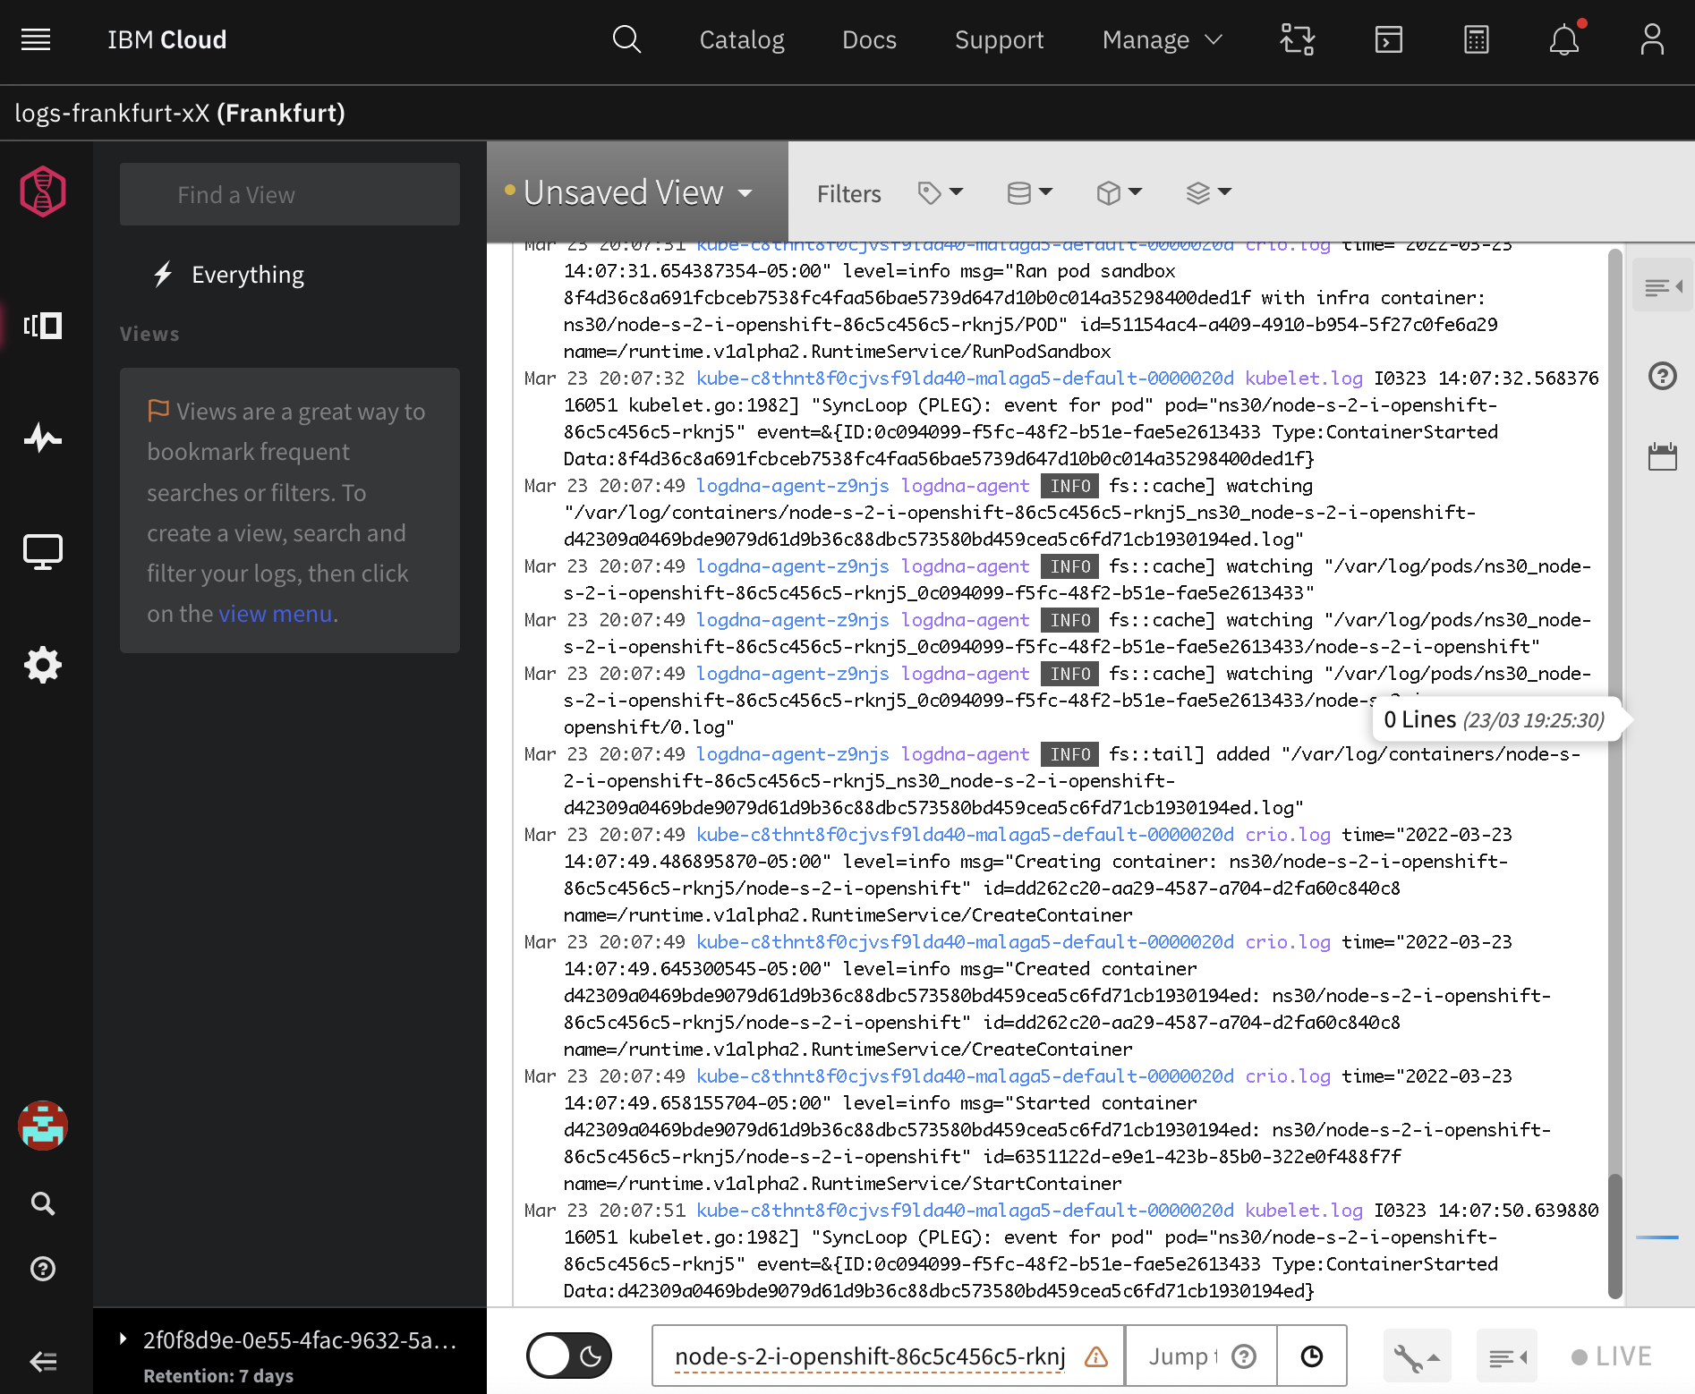

Or Click the Source identifier for the entry. Click the “+” icon. And press enter in the search field:

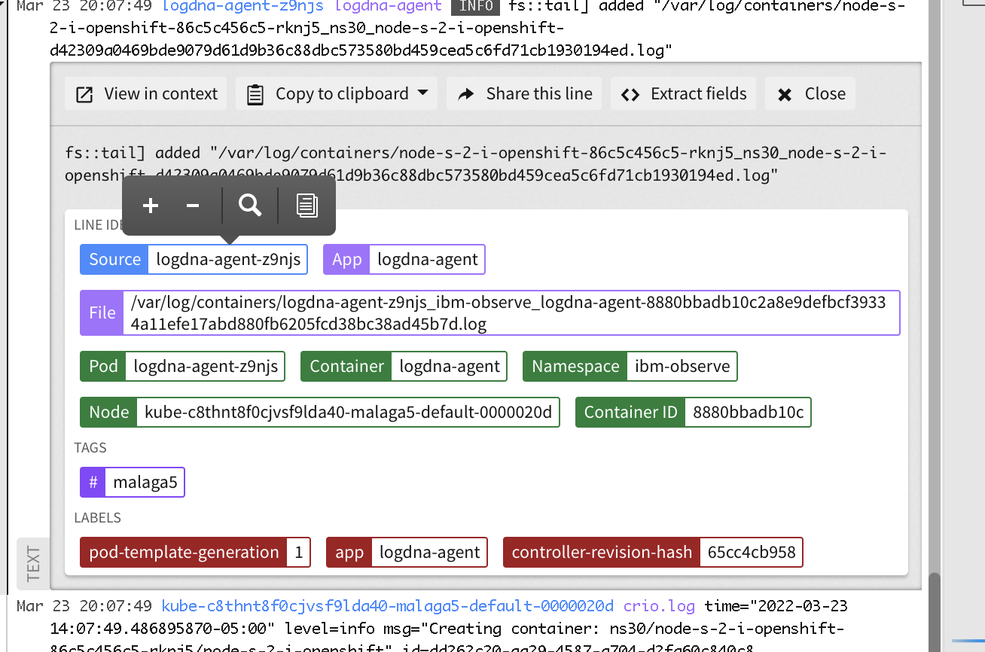

# Lab 5. Monitoring

Go to Monitoring:

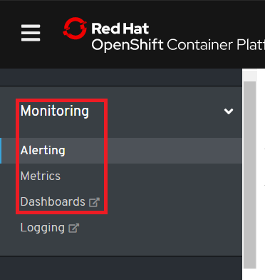

In this section you have access to:

* Alerting: out of the box alerts configured against Prometheus metrics.
* Metrics: Prometheus UI to query metrics.
* Dashboards: Access to Grafana.

## Dashboards

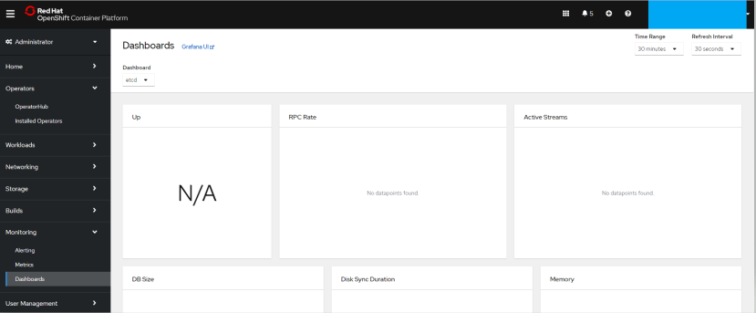

There are some generic dashboards (you cannot modify them). You can filter using the top combo boxes:

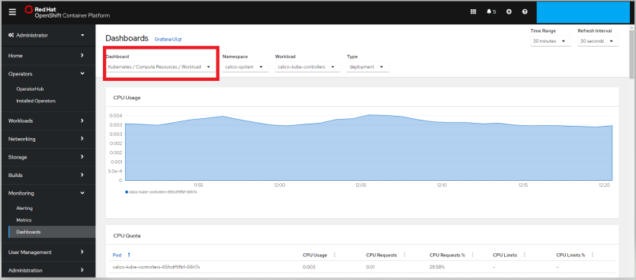

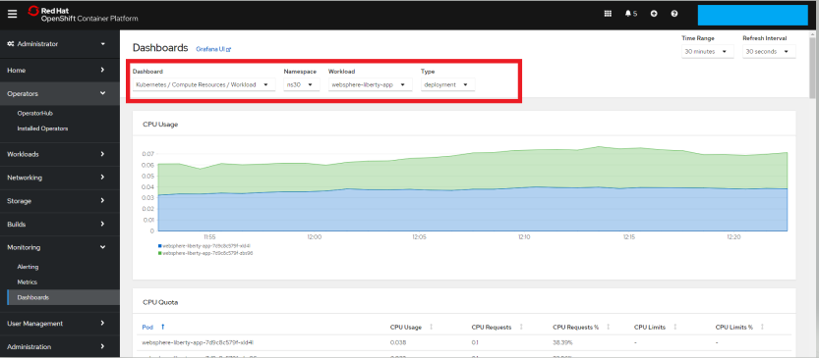

## Using IBM Cloud Monitoring Service

As we are using OpenShift on IBM Cloud we are going to use the IBM Cloud Monitoring Service in order to centralize all clusters and services monitoring.

You can access via Genera Menu -> Observability



Go to Monitoring and Select “Open dashboard” . It’ll open another tab:

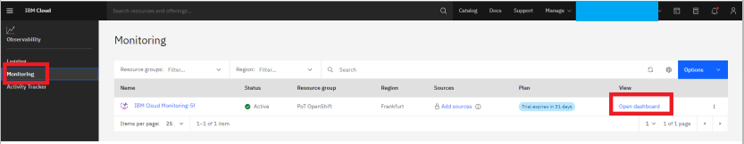

If you opened the Monitor immediately after it was created, you might see "No data available!" in many of the monitors. This is expected as the time interval is set to 1 hour be default and monitoring has only been running for a short period of time.

At the very bottom of the screen is the Time Navigation bar. This bar allows you to modify the time and date range of the current view. Modifying these parameters allows you to look back in time and get a closer look at a specific period of time.

The default view is Hosts & Containers:

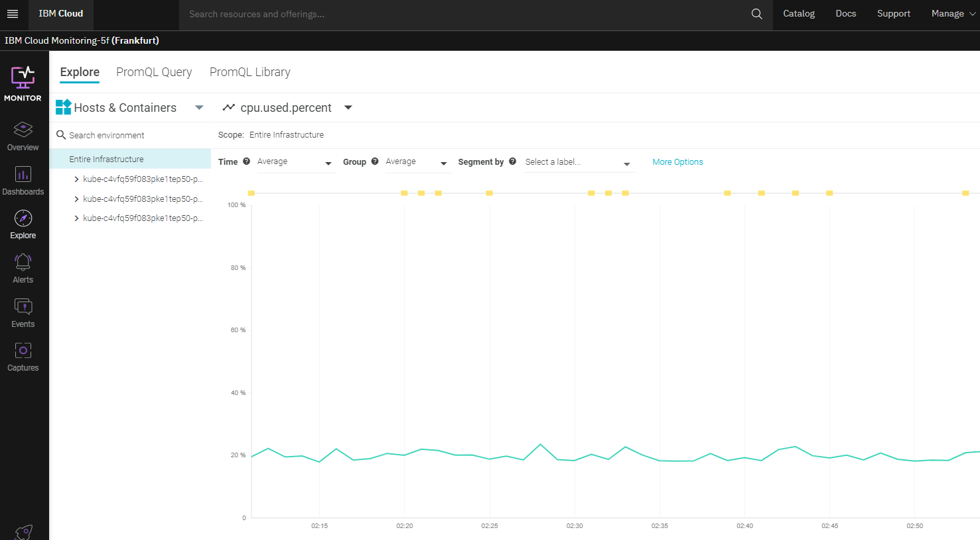

In the Dashboards tab, you monitor data by using any of the default dashboards or by creating new ones. In the Explore tab, you can monitor data by using default metrics and default dashboards.

Dashboard > Pods Status & Performance

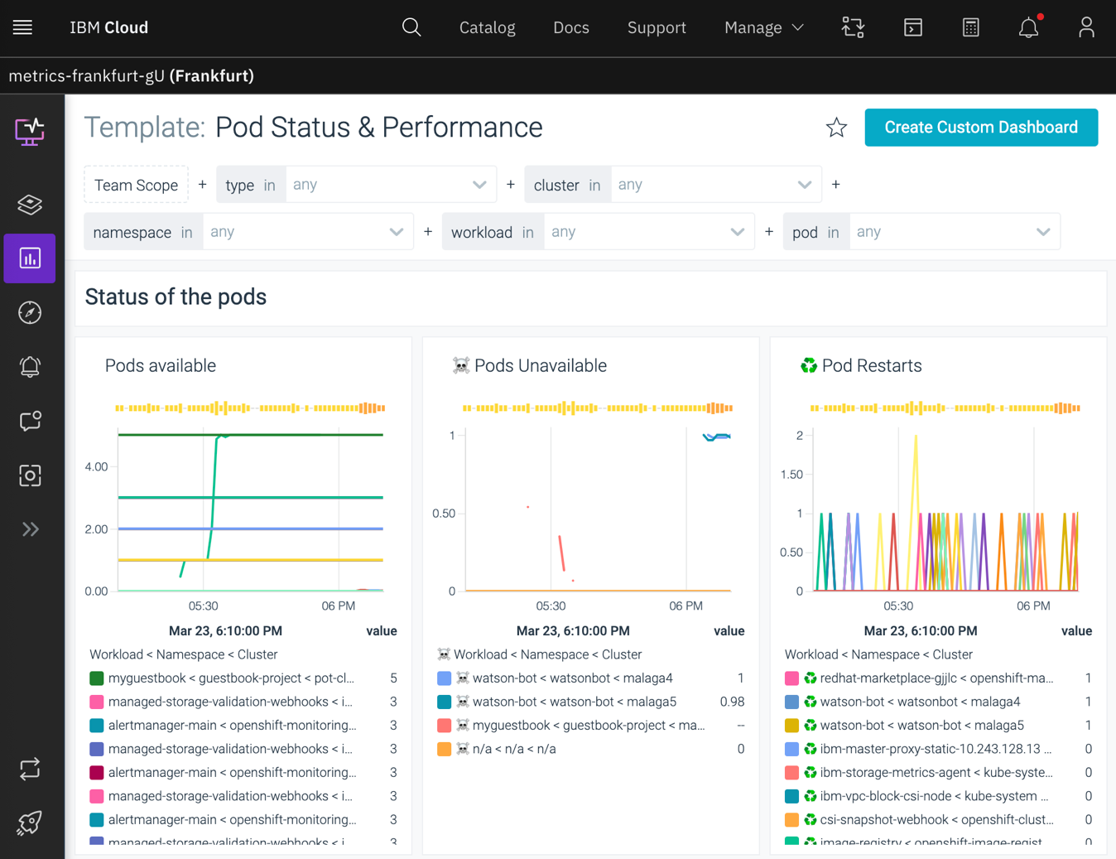

Dashboard > Workload Status & Performance



 